WEEK – 1 [03rd - 07th August – 2026]
03rd Aug 2026 [Monday]
- Completed Onboarding and iteracted with the team and gained understanding of the work environment.
04th Aug 2026 [Tuesday]
- Assigned initial tasks by Ratna, to setup flowise, understand the fundamental of Flowise , Git, ML algorithms.
- Installation and Setup of Flowise.
- Brushed up Machine Learning Fundamentals and Algorithms.
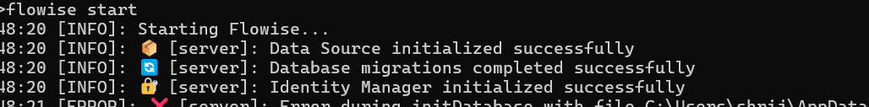

Flowise setup
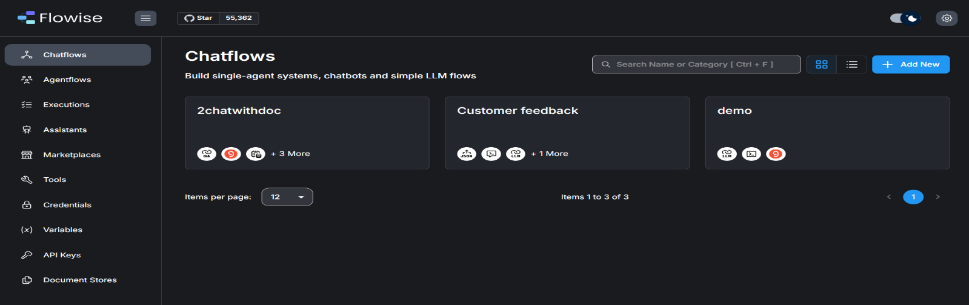

Flowise Dashboard
05th Aug 2026 [Wednesday]
- Learned fundamentals of Flowise, Prompt Engineering, prepared a use case.
Use-Case:
AI Health Information & Symptom Guidance Assistant:
- Users can ask questions about common symptoms, medicines, and general health concerns, and the application will provide simple, easy-to-understand explanations.
- It will analyze the symptoms shared by the user and suggest possible health conditions for awareness purposes, without providing a final diagnosis or medical conclusion.
- It will explain medicines by describing their common uses, precautions, and frequently reported side effects, helping users better understand their prescribed medications.
- The application will answer general healthcare and wellness questions using trusted, easy-to-understand language suitable for users without a medical background.
-The application will never prescribe medicines, recommend personalized dosages, or replace professional medical advice. Instead, it will always encourage users to consult a qualified healthcare professional for proper diagnosis and treatment whenever necessary.
- Built a demo Chatflow to understand Flowise nodes, connection of nodes, and execution flow.
- Tested web integration by embedding the chatbot into a sample webpage and observing its real-time functionality.
- Attending a meeting with Sujoy.
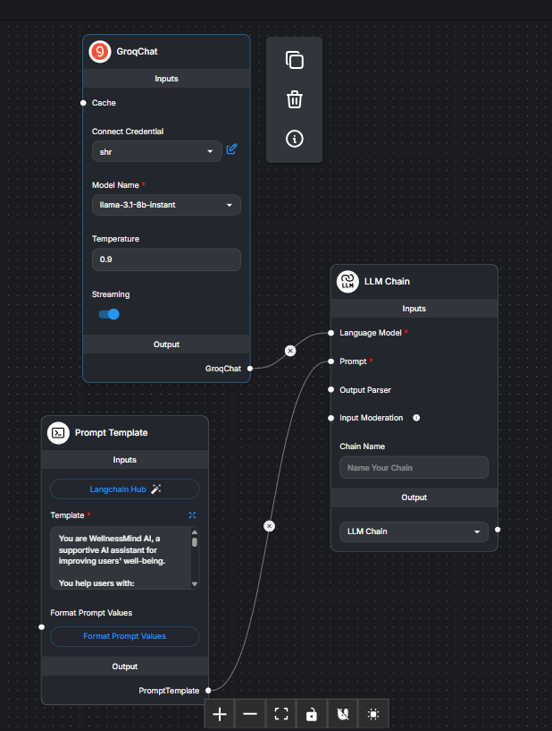
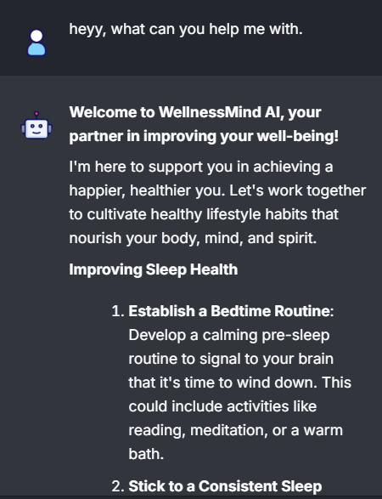

First basic Chatflow canvas showing LLM connected to User Input.
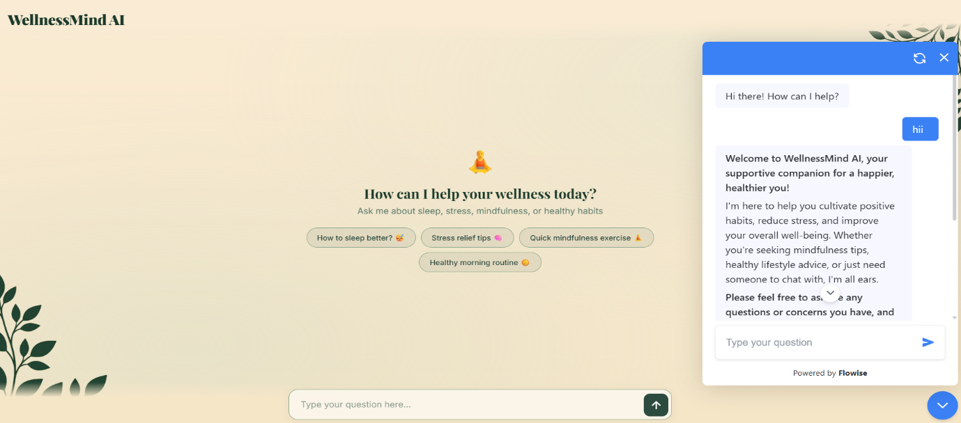
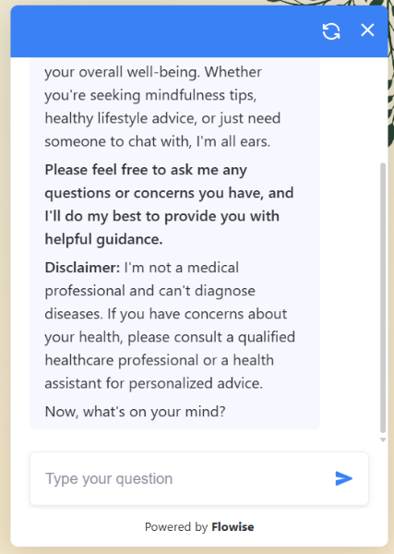

Sample HTML page rendering the embedded floating chatbot widget
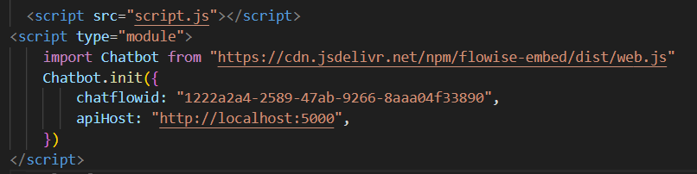

Snippet code

06th Aug 2026 [Thursday]
- Explored more features and functionalities of Flowise and built a document-based chatbot in Flowise.
- Learned how documents are processed through chunking, embedding, retrieval, and context-aware response generation.
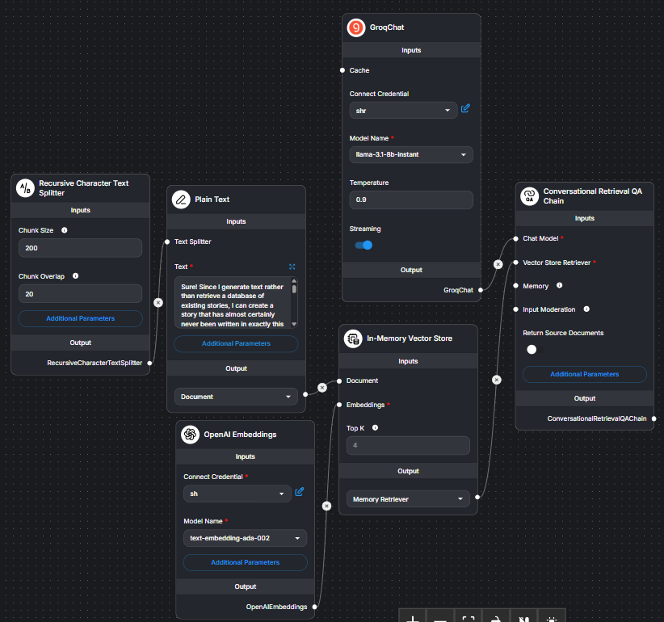

07th Aug 2026 [Friday]
- Learned the fundamentals of Retrieval-Augmented Generation (RAG), including its pipeline and architecture.
- Explored Flowise Agentflows, learned about embeddings and vectorization.
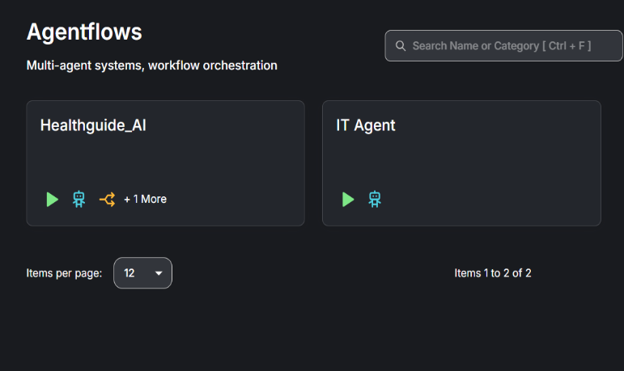
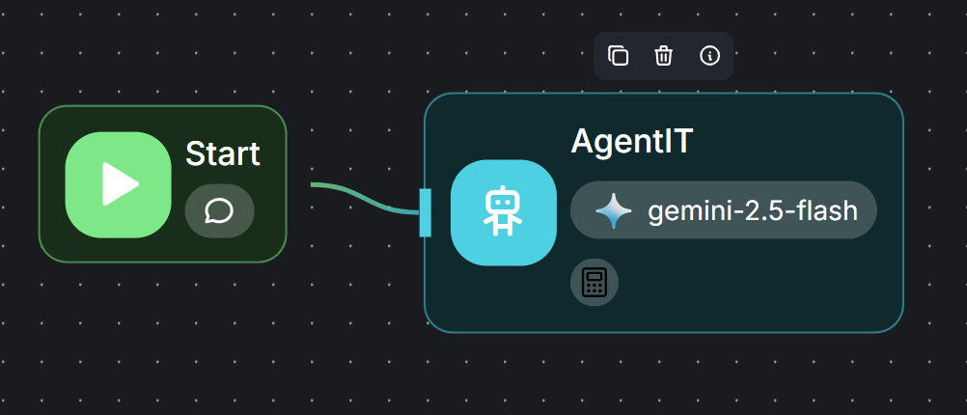

WEEK – 2 [10th - 12th August – 2026 ]
10th Aug 2026 [Monday]
- Gained an understanding of different nodes, their roles, and working of RAG including document loading, text splitting/chunking, embeddings, and vector stores.
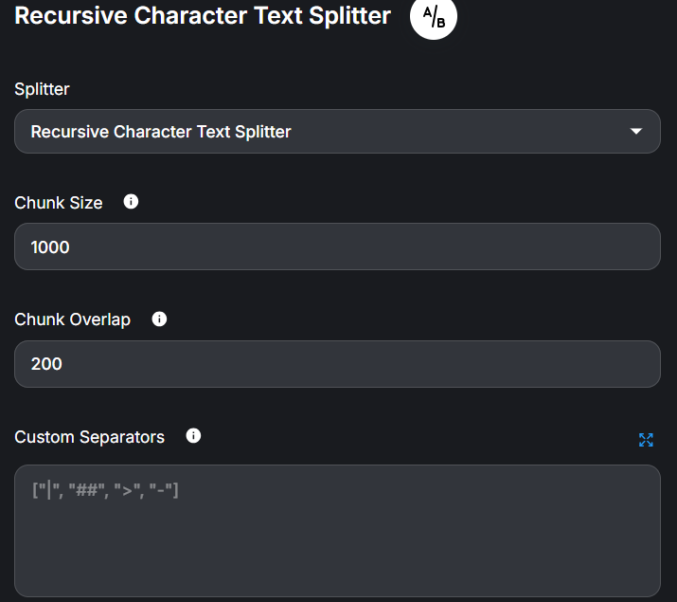
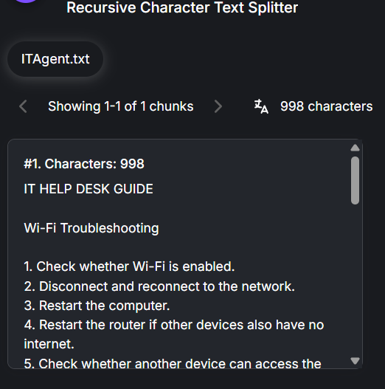

11th Aug 2026 [Tuesday]
- Implemented an Agentflows using an AI IT Helpdesk Agent use case.
- Tested multiple LLM providers, including Gemini, Groq, and Ollama.
- Built and tested the document embedding and vector database setup.
- Faced difficulties with Ollama embedding during Upsert Chunks.
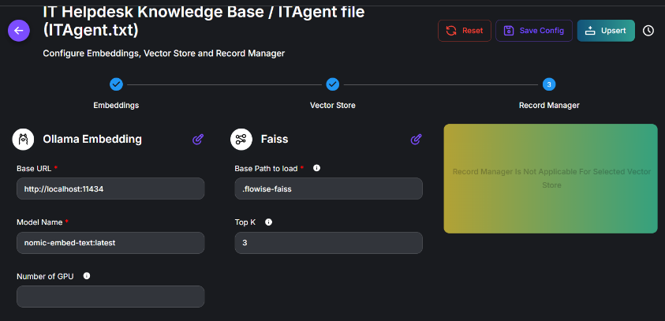
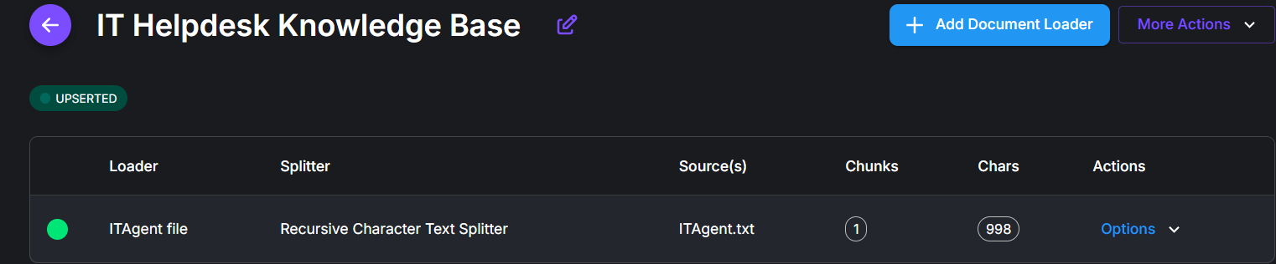

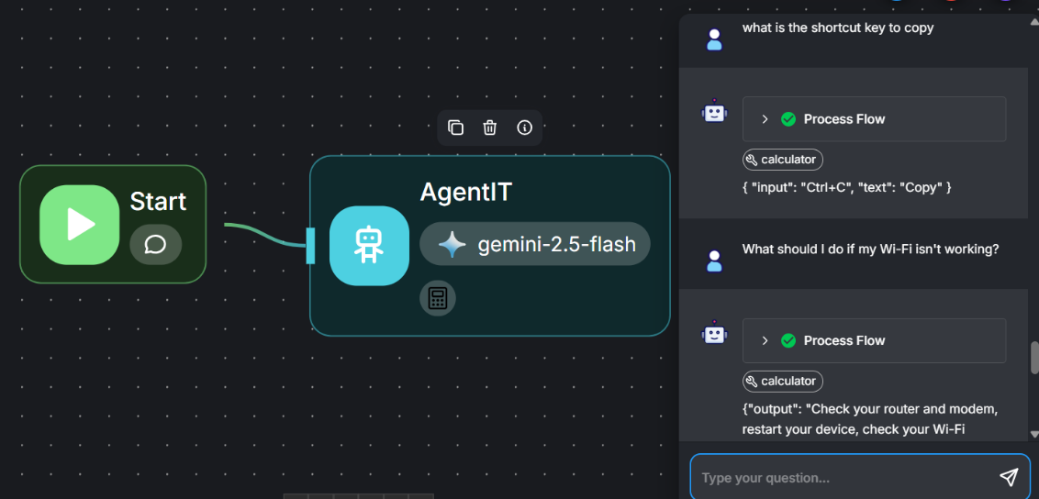
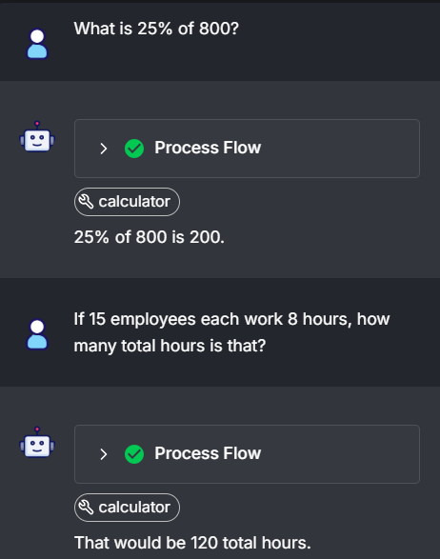

12th Aug 2026 [Wednesday]
- Built and finalized the HealthGuide AI Agentflow architecture on Flowise.
- Added and processed verified medical reference documents using Recursive Text Splitter and embeddings in the Document Store.
- Implemented a custom emergency symptom checker tool with conditional routing to handle emergency-related queries.
- Configured system prompt to maintain medical safety, avoid diagnosis or prescription, and provide appropriate disclaimers.
- Had a meeting with Ratna and presented a demo of the HealthGuide AI Agentflow.
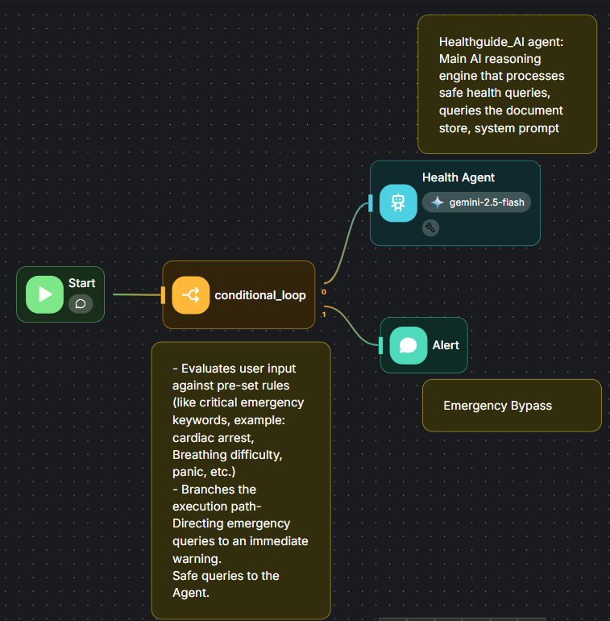
- Had a meeting with Sujoy regarding the work completed and the latest updates.
